

**Mathematics Specialist**

**Unit 4**

**2017**

**TEST 5**

Differential Equations, SHM, Sample Means

**Student name:** _______________________  **Teacher name:** _______________________

**Time allowed for this task: 40 *minutes***, in class, under test conditions

Calculator-Assumed

**Materials required:**

Standard items: Pens (blue/black preferred), pencils (including coloured), sharpener, correction fluid/tape, eraser, ruler, highlighters, SCSA Formula Sheet.

Classpad Calculator and Scientific Calculator.

Special items: Drawing instruments, templates

**Marks available: *39 marks***

**Task weighting: 8%**

Question 1 (7 marks)

(a) A particle undergoing simple harmonic motion with a period of 5 seconds is observed to move in a straight line, oscillating 3.6 m either side of a central position. Determine the speed of the particle when it is 3 m from the central position. (3 marks)

(b) Another particle moving in a straight line experiences an acceleration of ms-2, where is the position of the particle at time $t$ seconds.

Given that when $x=1$, the particle had a velocity of 2 ms-1, determine the velocity of the particle when $x=2$. (4 marks)

Question 2. (8 marks)

Lengths of climbing rope produced by a manufacturer over a long production run have breaking strengths that are normally distributed with a mean of 180.2 kg and standard deviation of 9.5 kg.

(a) Determine the probability that the mean breaking strength of a randomly chosen sample of 10 lengths will be less than 175 kg. (3 marks)

(b) At the start of a production run, a supervisor at the factory randomly samples 20 lengths and after testing, determines that the mean breaking strength of the sample is 176.9 kg. Construct a 90% interval estimate for the population mean based on this sample.   (2 marks)

(c)   If the supervisor repeated the same sampling process in (b) every day for 30 consecutive days, how many of the intervals constructed would be expected to include the known mean breaking strength of 180.2 kg? (1 mark)

 (d)   How large a sample should the supervisor take so that the width of a 95% confidence interval for the mean breaking strength has a width of no more than 5 kg?   (2 marks)

Question 3. (12 marks)

(a) A first-order differential equation is given by $\frac{dy}{dx}=\frac{xy}{2}$

(i) Use the equation to complete the table below. (2 marks)

|  |  |  |  |  |  |  |
| --- | --- | --- | --- | --- | --- | --- |
| *x* | -2 | -1 | 0 | 1 | 2 | 3 |
| *y* | 2 | 2 | 2 | 2 | 2 | 3 |
| $$\frac{dy}{dx}$$ |  |  |  |  |  |  |

(ii) Create a slope field on the 10 points on the graph below. (2 marks)

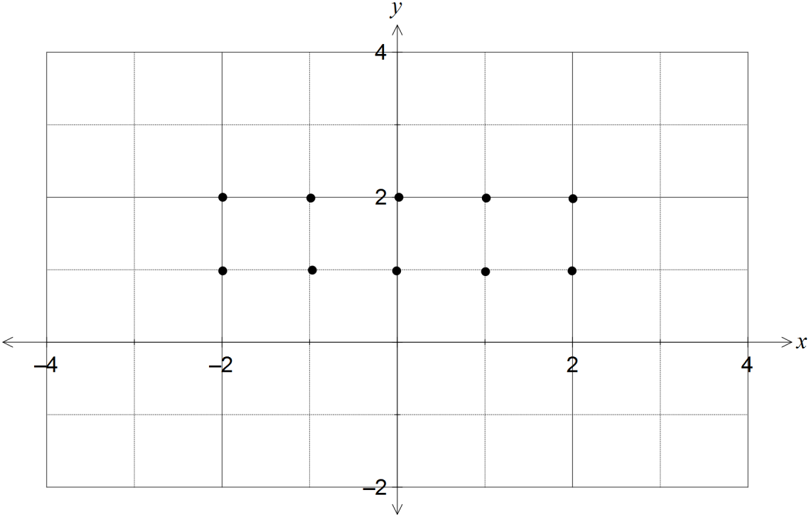

(iii) On the graph, sketch the solution curve to the differential equation that passes

through the point (3, 3). (2 marks)

(b) The differential equation for a curve passing through the point (0, 1) is given by $\frac{dy}{dx}=\frac{2}{x^{2}+2x+1}$

The slope field for the differential equation is shown below.

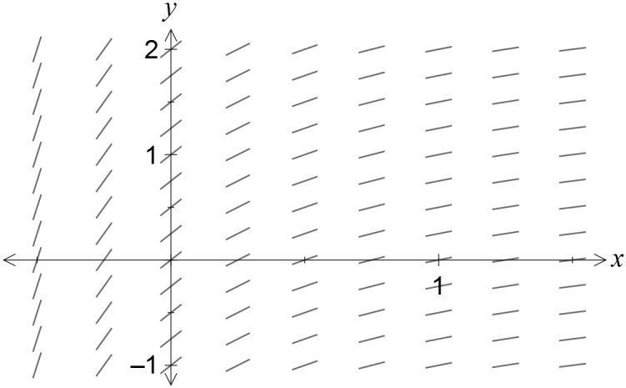

(i) Use the incremental formula, , with *x*  0.1, to calculate an estimate

for the y-coordinate of the curve when *x*  0.2. (4 marks)

(ii) Explain whether the estimate in (a) is an over- or under-estimate for the y- coordinate.

(2 marks)

Question 4. (12 marks)

(a) Given  find an expression for  in

terms of and  (**HINT: Use partial fractions. Show working)** (5 marks)

(b) The maximum number of trout that can be sustained in a dam is close to 610.

In January 2015, the number of trout was estimated to be 300, and by January

2016, the number had grown to 400.

(i) Use the logistic model to predict the number of trout in the dam in January 2017. (5 marks)

(ii) When will the number of trout reach 600? (2 marks)